**Advance Excel Assignment 1**

1. What do you mean by cells in an excel sheet?

Ans. In Microsoft Excel, a cell is a rectangular box that occurs at the intersection of a vertical column and a horizontal row in a worksheet. Vertical columns are numbered with alphabetic values such as A, B, C. Horizontal rows are numbered with numeric values such as 1, 2, 3.

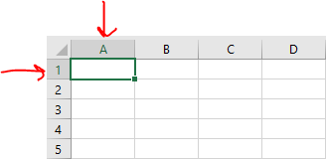

Each cell has its own set of coordinates or position in the worksheet such as A1, A2, B7 etc. In the above example, It is positioned on cell A1 which is the intersection of column A and row 1.

A cell can only store 1 piece of data at a time. A cell can store data such as a formula, text value, numeric value, or date value.

1. How can you restrict someone from copying a cell from your worksheet?

Ans. To prevent other users from accidentally or deliberately changing, moving, or deleting data in a worksheet, we can lock the cells on our Excel worksheet and then protect the sheet with a password.

To set a password to protect cells, follow the steps given below:  
  
1) Go to “Review Tab” and click on “Protect Sheet” option.

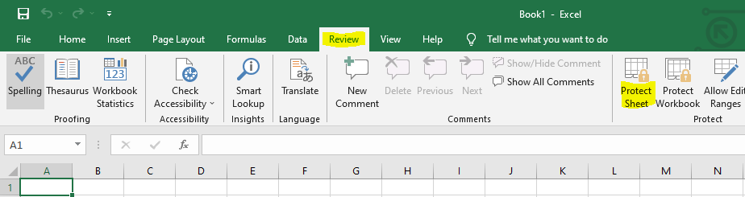  
  
2) Excel opens the Protect Sheet dialog box. By default, Excel selects the Protect Worksheet and Contents of Locked Cells check box.

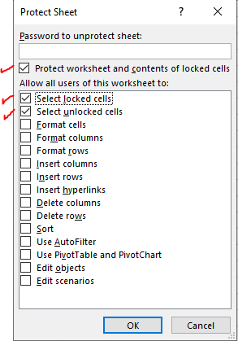  
  
3) Select any of the check boxes in the Allow All Users of This Worksheet To list box (such as Format Cells or Insert Columns) that you still want to be functional when the worksheet protection is operational.  
The Select Locked Cells and Select Unlocked Cells check boxes are selected by default as shown in above image.  
  
4) Type the password in the “Password to unprotect Sheet” text box.  
  
5) Click OK.  
  
6) Excel opens the Confirm Password dialog box. Re-enter the password in the Reenter Password to Proceed text box and then click OK.

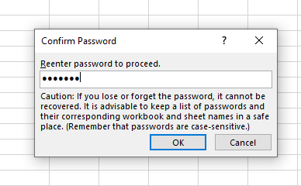

Note : If you try to edit a cell, Excel displays an error message.

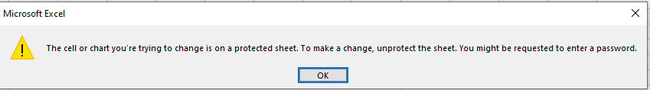

1. How to move or copy the worksheet into another workbook?

Ans. The common way to copy a sheet to another workbook is this:

* Right click on the tab that you want to copy, and then click Move or Copy.
* In the Move or Copy dialog box, follow the below steps:
  + Under To book, choose the target file. To place a copy into a new workbook, select (new book).
  + Under Before sheet, specify where to put the copy.
  + Select the Create a copy box.
  + Click OK.

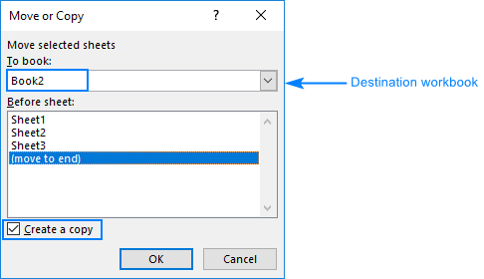

Note: Excel displays only the open workbooks in theTo book drop-down list, so be sure to open the destination file before copying.

There is another way also to copy the worksheet into another workbook by DRAGGING:

1. Open the source and target workbooks.
2. On the View tab, in the Windows group, click View Side by Side. This will arrange the two workbooks horizontally.
3. In the source workbook, click the sheet tab you'd like to copy, hold down the ctrl key and drag the sheet to the target workbook.

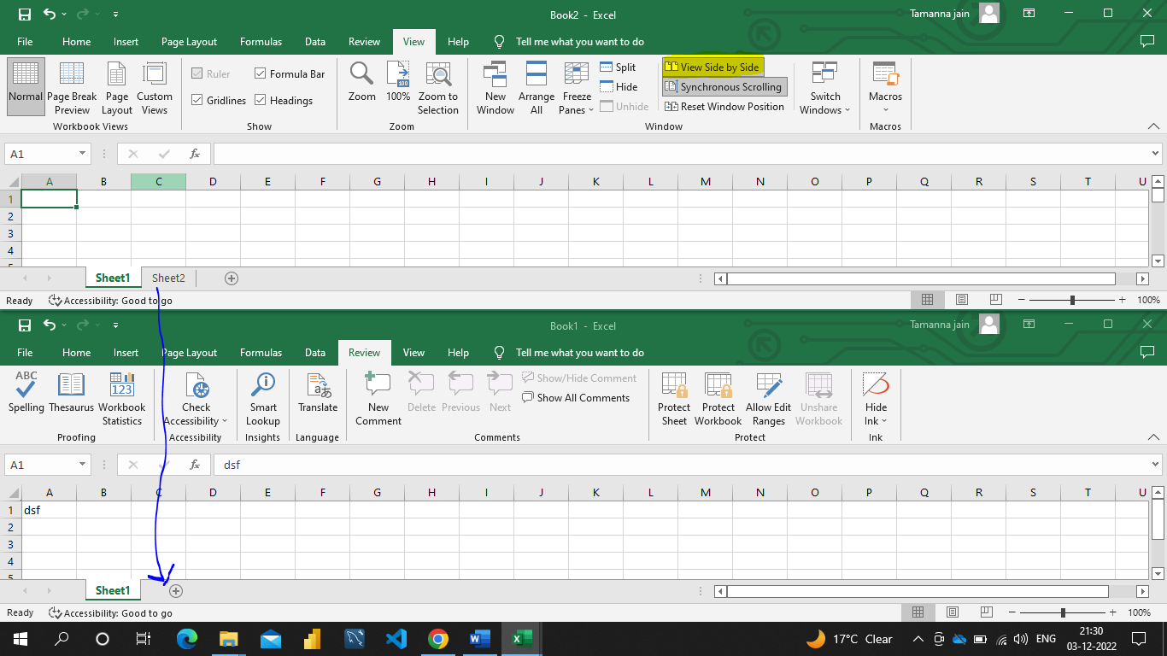

1. Which key is used as a shortcut for opening a new window document?

Ans. CTRL + N is the shortcut for opening a new window document.

1. What are the things that we can notice after opening the Excel interface?

Ans. The interface components of Excel include the Quick Access Toolbar, Ribbon, Name Box, Formula Quick Menu, Formula Bar, Status Bar, Worksheet View Options, Zoom Slider Control, and the Zoom Percentage Indicator.

  Quick Access Toolbar :

The Quick Access Toolbar is found on the top-left of the Excel window which contains the commonly-used commands in Excel. This toolbar can be customized and lets you choose which commands you want to access easily. By default, this contains the save, undo, and redo commands.

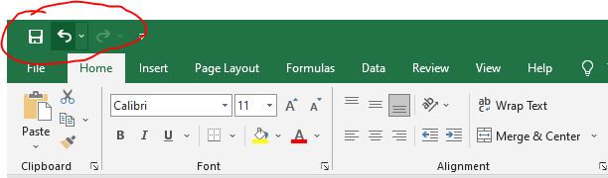

Ribbon :

The Ribbon interface contains the commands that are available for use in Excel. This has multiple tabs including the File, Home, Insert, Page Layout, Formulas, Data, Review, View, Add-ins, and Help tabs. There are tabs that will appear when necessary; for example, the Format tab appears when you click an inserted shape.

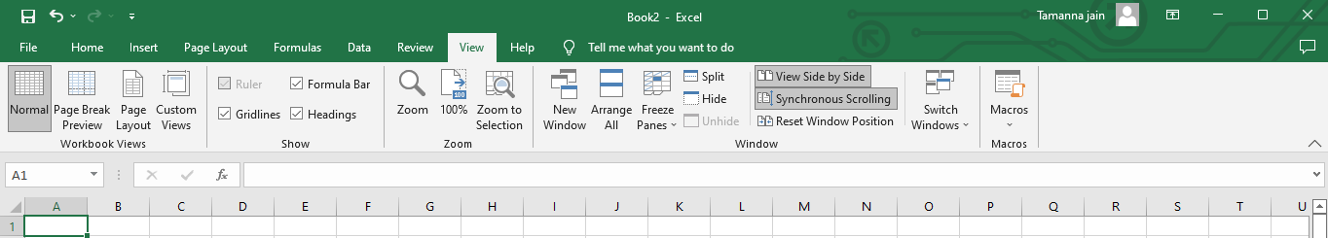

Name Box :

The Name Box is an input box which normally displays the name or location of the active cell on the worksheet. This is also used to directly create a named range. When you open a blank workbook, the selected cell is A1, by default.

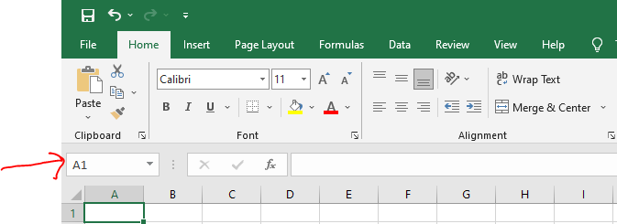

Formula Quick Menu :

The Formula Quick Menu beside the Name box is a shortcut when you want to insert a function. If you click the fxoption, the Insert Function will pop-up to let you choose which Excel function would you like to use.

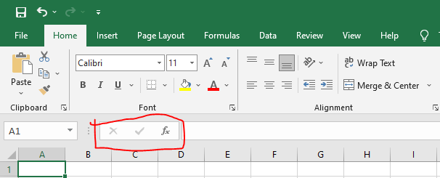

Formula Bar :

The Formula Bar is found just beside the Formula Quick Menu. This allows you to enter or edit data, formula or a function that will appear in the selected cell whose name or location appears in the Name Box.

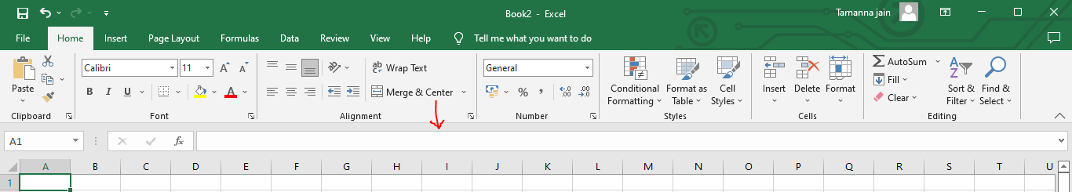

Status Bar :

The Status Bar in the bottom-left corner of the Excel window displays various information about the current mode of the workbook.

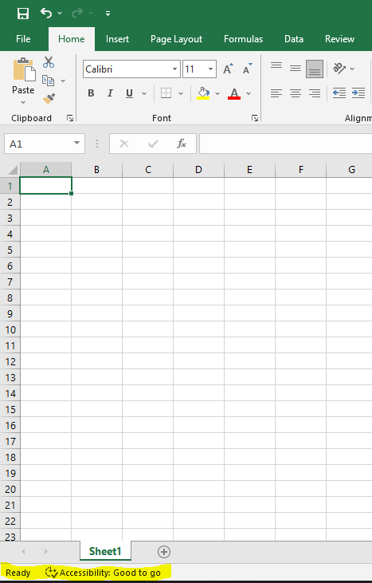

Worksheet View Options :

The Worksheet View Options lets you choose which of the 3 worksheet views you want (Normal, Page Layout, or Page Break Preview). By default, the worksheet view is set to Normal.

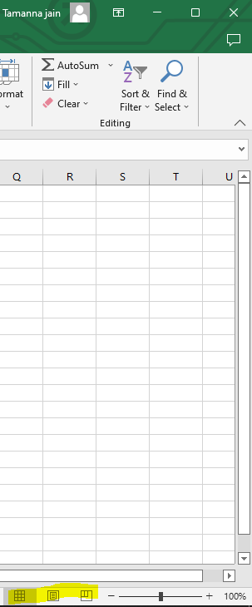

Zoom Slider Control :

The Zoom Slider Control helps you zoom in and zoom out the worksheet.

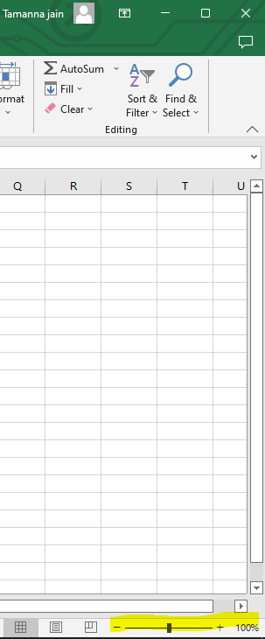

Zoom Percentage Indicator :

The Zoom Percentage Indicator displays the zoom percentage just beside the Zoom Slider Control. By default, it is set to 100%.

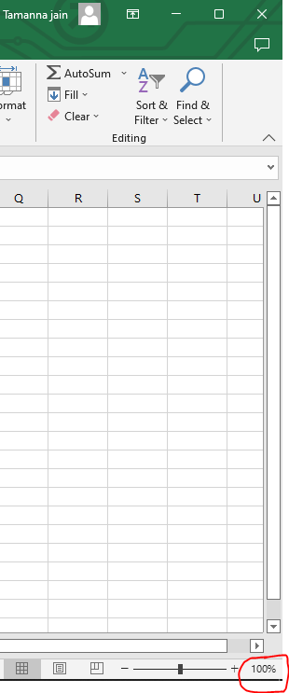

1. When to use a relative cell reference in excel?

Ans. Relative reference is a type of cell reference in Excel. This reference changes when the formula is copied to any other cell or any other worksheet. Relative cell references are used whenever calculations need to be repeated.

Example :

We want a summation of two numbers located in cells A1 & A2 and we want the sum in cell A3.

So, in cell A3, we applied “=A1+A2.”

